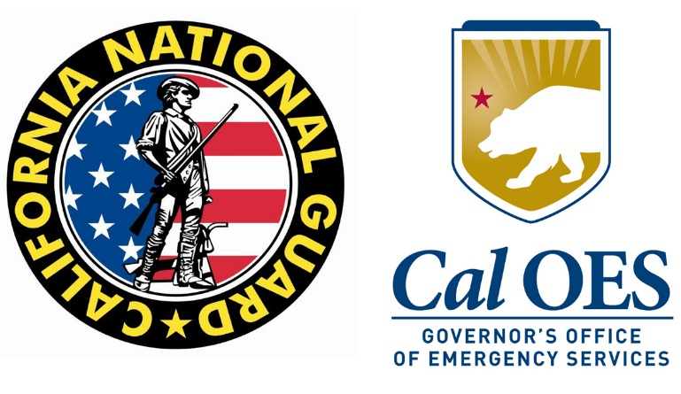

FOR IMMEDIATE RELEASE July 29, 2015
Cal Guard Contact: Capt. Will Martin (916) 799-9525 Release 07-05
Cal OES Contact: Brad Alexander (916) 502-5717

Cal Guard Launches Remotely Piloted Aircraft to Search El Dorado National Forest for Missing Person

SACRAMENTO, Calif. – At the request of the El Dorado County Sheriff’s Office and California Governor’s Office of Emergency Services, the California National Guard launched a Remotely Piloted Aircraft at 10:20 a.m. today to help search for 45-year-old Edward Kavanaugh who was last seen July 17 when he went motorcycle riding in the El Dorado National Forest. This is the first time such a vehicle has been used by the National Guard to aid a search-and-rescue effort.

“In 2013, the Cal Guard’s remotely piloted aircraft aided firefighters during the Rim Fire, and now — for the first time ever — it is helping an active search-and-rescue mission,” said Maj. Gen. David S. Baldwin, California’s Adjutant General. “This technology helps the search-and-rescue mission by traveling where manned aircraft cannot safely fly, and transmitting valuable information back to rescue crews.”

The remotely piloted aircraft, an Air National Guard MQ-9 Reaper, departed the March Air Reserve Base near Riverside, California this morning. Equipped with infrared sensors, image-intensified cameras and laser illuminators, it is bolstering the active search-and-rescue efforts in the national forest by providing detailed aerial pictures that are instantly relayed to National Guard ground crews and their civilian partners.

The El Dorado County Sheriff’s request for use of the remotely piloted aircraft came to the Cal Guard’s leadership last night through the California Governor’s Office of Emergency Services, which provides the Cal Guard oversight in its state emergency-response missions. On average, the Cal Guard responds to a state incident, including wildfires and search-and-rescue missions, once every three days.

“Having access to mutual aid resources like this is an amazing asset for our state and our local counterparts in times of crisis,” said California Governor’s Office of Emergency Services Director Mark Ghilarducci. “We hope that this aircraft is able to provide El Dorado County with valuable information to the on-the-ground personnel involved in this search-and-rescue mission.”

The Cal Guard has previously used its remotely piloted aircraft for state emergency-response missions when it supported firefighting efforts at Yosemite National Park during the 2013 Rim Fire. During that mission, the MQ-1 Predator provided aerial imagery in support of interagency firefighters on the ground as they battled the third-largest fire in California’s history.

The Cal Guard and California Governor’s Office of Emergency Services remind the public that privately owned “unmanned aircraft ” should not be flown near search-and-rescue or firefighting activities because this can interfere with public safety operations and put lives at risk.

For more information on the Cal Guard’s remotely piloted aircrafts and emergency-response missions, please Capt. Will Martin, public affairs officer, at (916) 799-9525. For information about the active search-and-rescue operation in the El Dorado National Forest, contact the El Dorado Sheriff’s Office at (530) 621-5655.

-30-

